# Add Skype Click-to-Call Phone Numbers into a Document or Web Page

Just like you are able to add links to Web sites and clickable email addresses, you can also format a phone number so that Skype users can click-to-call the number.

## Add a Click to Call Link into a Document

In your document:

* Highlight the phone number, then go to **Insert > Hyperlink**.

The **Insert Hyperlink** window appears.

* In the **Address** field: type [**tel:XXX-XXX-XXXX**](tel:XXX-XXX-XXXX) **Click OK.**

IMPORTANT: Make sure there are no spaces between ‘tel:’ and the number. No need to enter a 1 or 9. Number formatting must be correct: 123-567-8901, 1234567890 or (234) 123-6789.

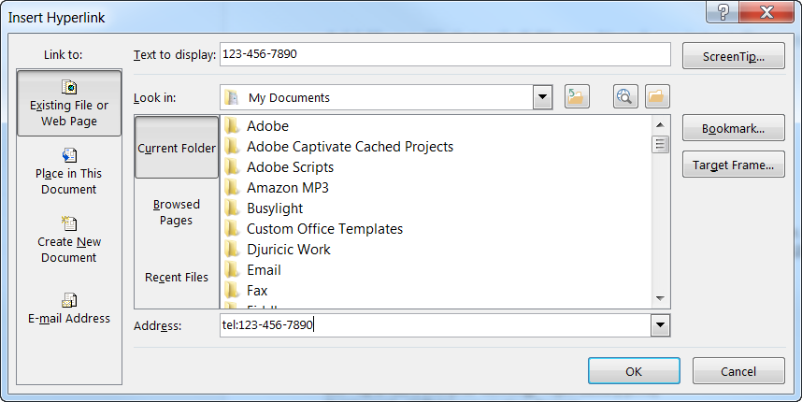

## Add a Click to Call Link into a Web Page

You have multiple options to add click-to-call numbers into a Web page.

For a standard Web page, just format the phone number as (414) 123-5678 and the browser does the rest by inserting the Skype phone icon next to the number.

For a Sharepoint page, you can highlight the number, then from the editing toolbar click **Insert > Link**.

In the **Address** line, type <tel:xxx-xxx-xxxx>. Click **OK**.

